COAL LAB (LAB 2)  
Name: Adnan Hatim  
Section: BCS-3F  
Student_ID: 24K-0656

**TASK 1:**

Code:

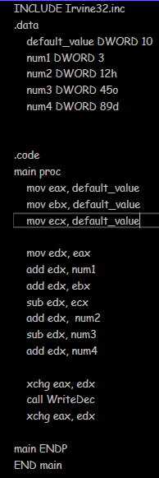

Output:

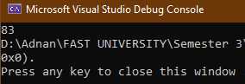

**TASK 2:**

Code:

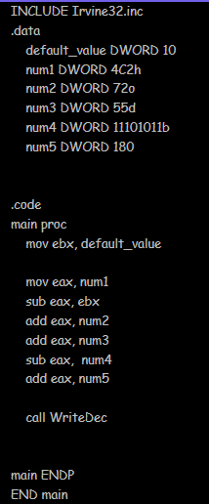

Output:

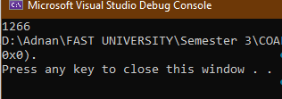

**TASK 3:**

Code:

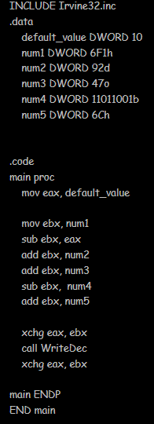

Output:

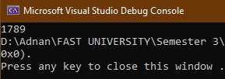

**TASK 4:**

Code:

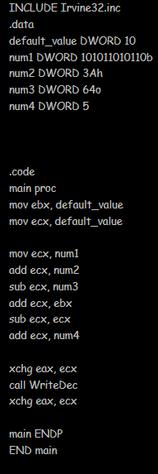

Output:

